Angularjs apps use Data APIs

1.JSON data is the easiest to use

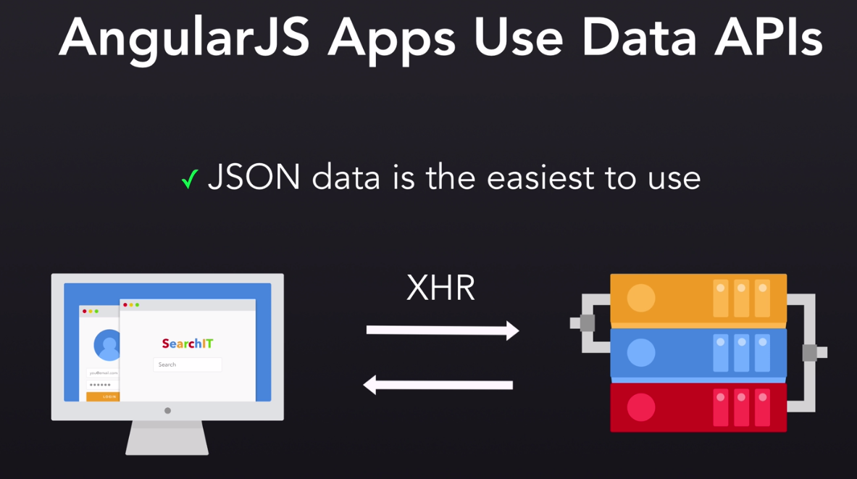

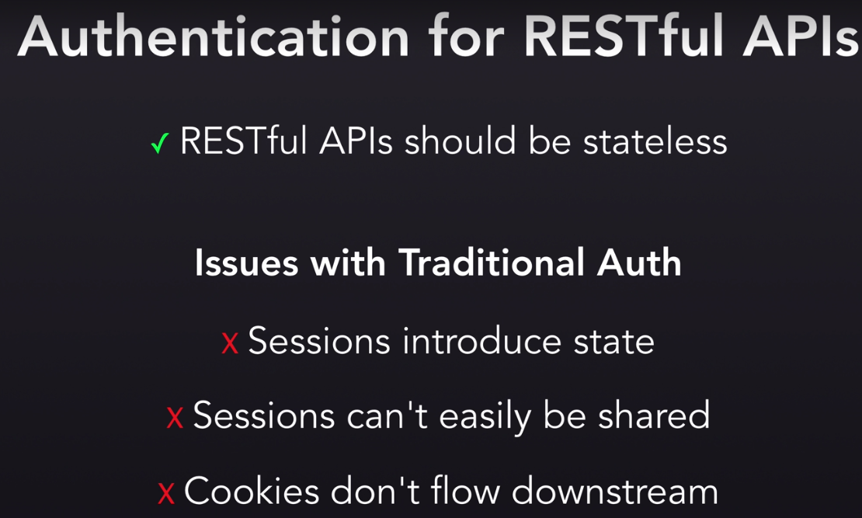

Authentication for angularjs apps:

Routs access should be controlled

Need some indication of authentication

Conditionally show and hide UI elements

JSON web token:

1. Securely transmit claims
2. Communicate a JSON payload
3. Information about a user

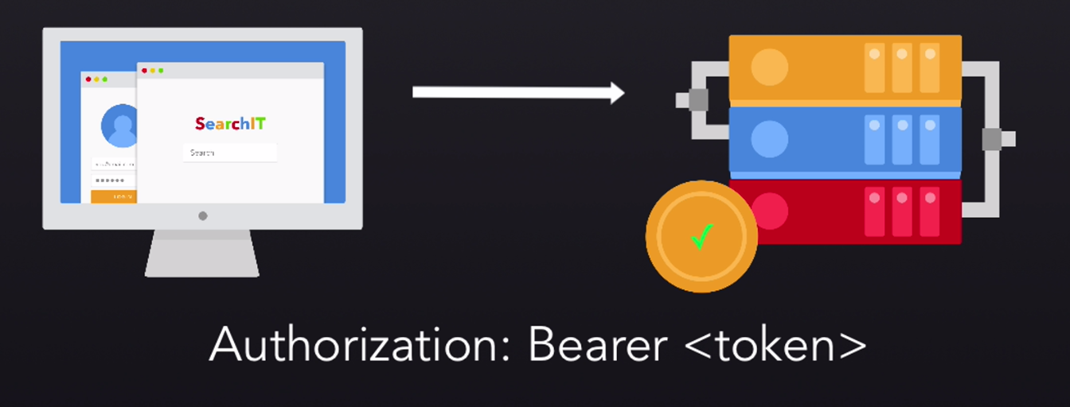

AuthO uses:

1. Social login
2. Multi factor auth
3. Single sign on
4. Passwordless login

Game Plan:

1. Sign up for Auth0
2. Simple angularjs front end
3. Simple nodejs backend with express
4. Send the JWT as an authorization header